Bryan Emer
DSC 650
Final Project

End-to-End Big Data Pipeline: Spotify Tracks Popularity Prediction

Introduction
The objective of this final project was to design and implement a complete end-to-end data pipeline integrating six major components of the Hadoop and Spark ecosystem: Apache NiFi, HDFS, YARN, Apache Hive, Apache HBase, and Apache Spark with MLlib. The pipeline was built inside a Docker-based environment running on a Google Cloud virtual machine with 8 vCPUs and 16 GB of RAM.
The pipeline follows a logical data flow: NiFi ingests a raw CSV dataset from GitHub and writes it to HDFS for distributed storage. From HDFS, the data is loaded into a Hive managed table for structured querying and schema enforcement. A PySpark MLlib job then reads from Hive, trains a Random Forest regression model to predict track popularity from audio features, evaluates model performance, and writes the resulting metrics to an HBase NoSQL table for persistence. The final HBase scan confirms that all components of the pipeline executed successfully in sequence.
This project demonstrates the ability to work across the full Hadoop ecosystem in a realistic distributed computing environment, including diagnosing and resolving real-world errors encountered during execution.

Dataset
Dataset Name: Spotify Tracks Dataset
Source: Kaggle - maharshipandya/spotify-tracks-dataset
GitHub Direct URL: https://raw.githubusercontent.com/bemer303/bigdata/refs/heads/main/spotify_dataset.csv
File Name: spotify_tracks.csv
Row Count: ~114,000 tracks
Format: CSV with header row

The dataset contains audio feature metadata for approximately 114,000 Spotify tracks across 114 genres. Each row represents one track and includes the following 21 columns:
Column | Type | Description
row_num | STRING | Unnamed Kaggle index column
track_id | STRING | Spotify track identifier
artists | STRING | Artist name(s)
album_name | STRING | Album title
track_name | STRING | Track title
popularity | INT | Popularity score 0–100 (target variable)
duration_ms | INT | Track length in milliseconds
explicit | INT | Explicit content flag (0/1)
danceability | FLOAT | Danceability score 0.0–1.0
energy | FLOAT | Energy level 0.0–1.0
track_key | INT | Musical key (0–11)
loudness | FLOAT | Overall loudness in dB
mode | INT | Major (1) or minor (0)
speechiness | FLOAT | Presence of spoken words
acousticness | FLOAT | Acoustic confidence 0.0–1.0
instrumentalness | FLOAT | Instrumentalness 0.0–1.0
liveness | FLOAT | Presence of live audience
valence | FLOAT | Musical positivity 0.0–1.0
tempo | FLOAT | Estimated BPM
time_signature | INT | Estimated beats per bar
track_genre | STRING | Genre label

This dataset was chosen because it contains a rich set of numeric audio features suitable for regression modeling, has enough rows (114K) to meaningfully train and evaluate an MLlib model, and is domain-relevant, making the results interpretable in musical terms.

Pipeline Overview
The pipeline integrates all six required components in the following sequence:
GitHub (CSV) → NiFi → HDFS → Hive → Spark MLlib (YARN) → HBase
Step 1 - NiFi (Data Ingestion):
Apache NiFi was used to download the Spotify CSV from a raw GitHub URL and write it to HDFS. The provided Final_Project.json template was imported into NiFi and configured with a Parameter Context containing four variables: DOWNLOAD FILE URL, FILENAME, HDFS WRITE DIRECTORY, and USER. The flow uses three processors: InvokeHTTP to download the file, UpdateAttribute to rename it, and PutHDFS to write it to /user/spotify in HDFS.
Step 2 - HDFS (Distributed Storage):
HDFS served as the central storage layer. The file was confirmed with hdfs dfs -ls /user/spotify, showing spotify_tracks.csv successfully written. HDFS provides fault-tolerant, distributed file storage that allows both Hive and Spark to access the data without copying it to local disk.
Step 3 - Hive (Data Warehousing):
A managed Hive table named spotify_tracks was created in a dedicated database spotify_db. The schema was designed to match the CSV's 21 columns including the unnamed index column. Data was loaded using LOAD DATA INPATH. Aggregation queries were run to verify that numeric columns were correctly populated across all rows.
Step 4 - YARN (Resource Management):
YARN served as the resource manager for the Spark job. All spark-submit commands used --master yarn, causing YARN to allocate containers across the master and worker nodes for distributed execution. YARN managed memory allocation and task scheduling throughout the MLlib training process.
Step 5 - Spark + MLlib (Machine Learning):
A PySpark script (spotify_ml.py) was submitted via spark-submit. The script reads data from the Hive table using SparkSQL, assembles 13 audio feature columns into a feature vector, trains a Random Forest Regressor to predict popularity, and evaluates the model using RMSE, R², and MAE metrics.
Step 6 - HBase (NoSQL Metrics Storage):
After model evaluation, the PySpark script wrote all metrics and model metadata to an HBase table named spotify_ml_metrics using the happybase Python library over the Thrift protocol. A final scan command in the HBase shell confirmed all eight columns were successfully written.

Issues Encountered
Issue 1 - YARN Memory Threshold Exceeded
Error: Required executor memory (2048 MB), overhead (384 MB) is above the max threshold (1536 MB)

Cause: The initial spark-submit specified --executor-memory 2g and --driver-memory 2g. The YARN cluster's per-container memory cap was 1536 MB, and 2048 + 384 MB overhead exceeded this limit.

Resolution: Reduced both flags to 1g (1024 MB + 384 MB overhead = 1408 MB), which fit within the 1536 MB cap. At this scale, 1g was sufficient for the 114K-row dataset

Issue 2 - StandardScaler Empty Partition Error
Error: java.lang.IllegalArgumentException: requirement failed: Nothing has been added to this summarizer

Cause: The pipeline originally included a StandardScaler stage between the VectorAssembler and RandomForestRegressor. When randomSplit divided the data, some partitions were empty, causing the StandardScaler's internal statistics summarizer to fail with nothing to process.

Resolution: Removed the StandardScaler entirely. Random Forest is a tree-based algorithm and does not require feature scaling. Unlike gradient-based or distance-based models, it is invariant to feature magnitude. Removing the scaler also simplified the pipeline without any loss of model quality. Additionally, df.repartition(4) was added to ensure balanced data distribution across partitions.

Screenshots
Objective 1 –
NiFi Flow Design, NiFi Flow Running -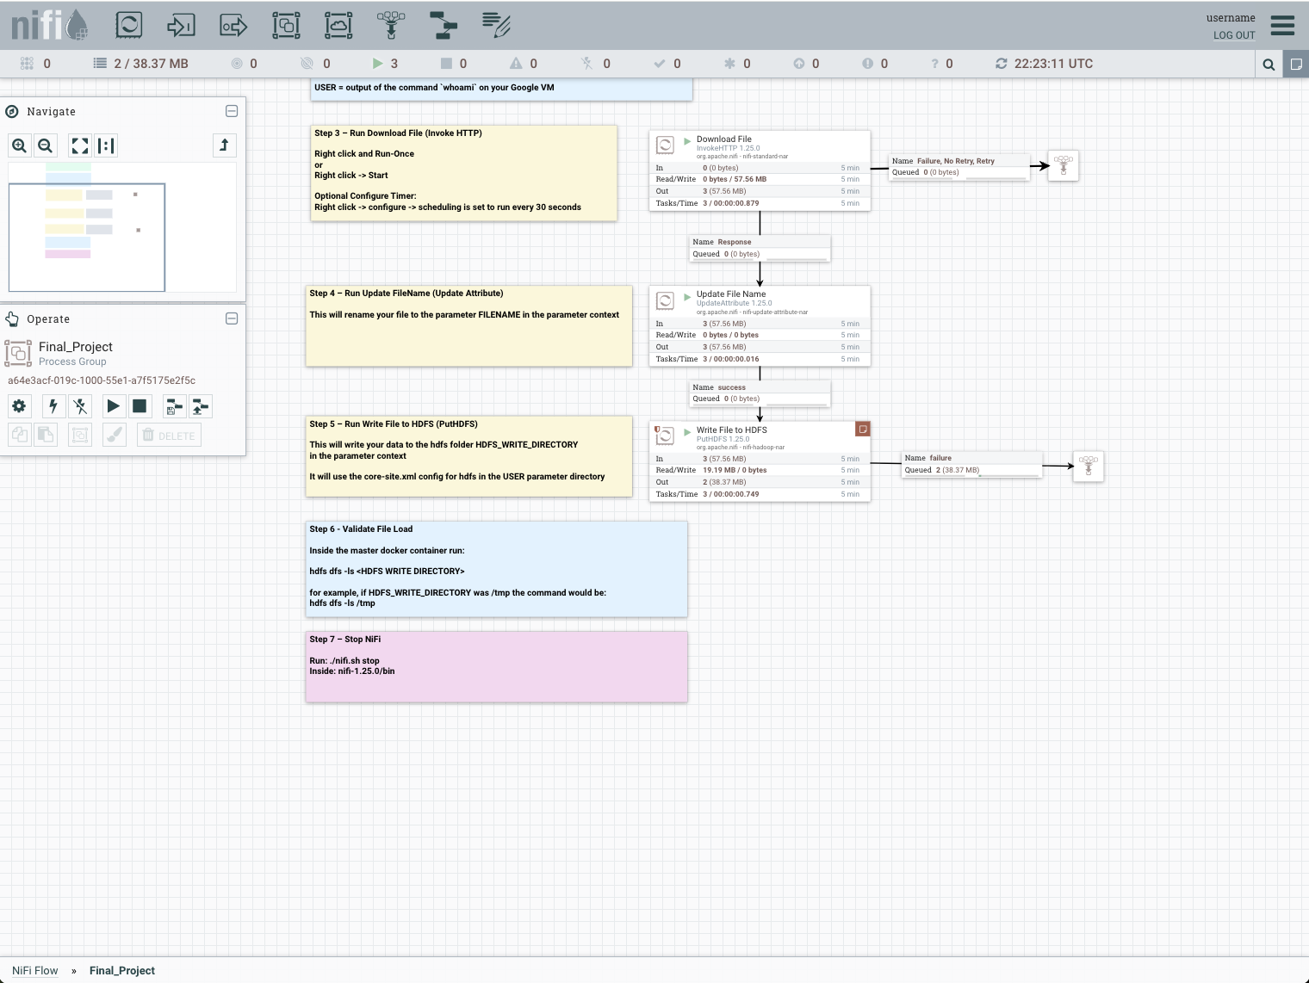

HDFS verification -
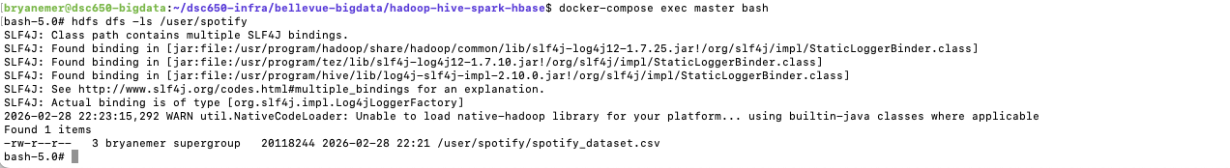
The NiFi pipeline uses three processors to ingest the Spotify Tracks dataset into HDFS. InvokeHTTP issues an HTTP GET to the raw GitHub URL and retrieves the CSV as a FlowFile. UpdateAttribute renames it to spotify_tracks.csv for consistent downstream references. PutHDFS writes the file to the /user/spotify HDFS directory using the Hadoop core-site.xml configuration. This mirrors real-world ingestion patterns where NiFi acts as a lightweight ETL broker between external sources and distributed storage.

Objective 2
Create Table statement -
Data successfully loaded into Hive -
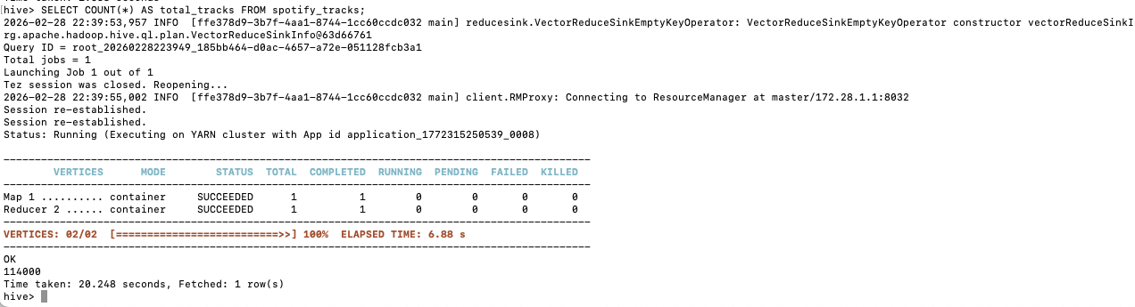
Aggregation query -
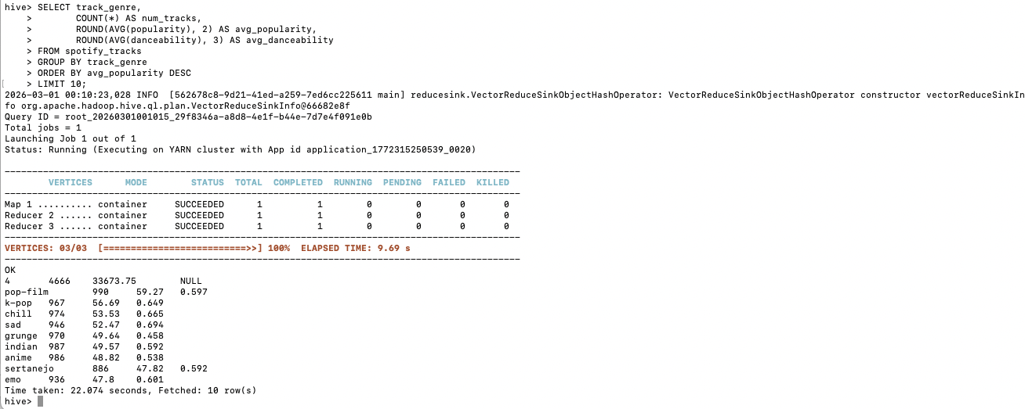
The Hive table spotify_tracks is designed as a managed TEXTFILE table with comma-delimited fields matching the Spotify dataset's CSV schema. Most audio feature columns (danceability, energy, tempo, etc.) are typed as FLOAT to preserve precision for ML modeling, while categorical fields like track_genre and artists use STRING. The skip.header.line.count table property ensures the CSV header row is ignored during loading. The aggregation query groups tracks by genre and computes average popularity and danceability, confirming that the schema is correctly mapped and data is fully populated.

Objective 3
Pip3 install output -
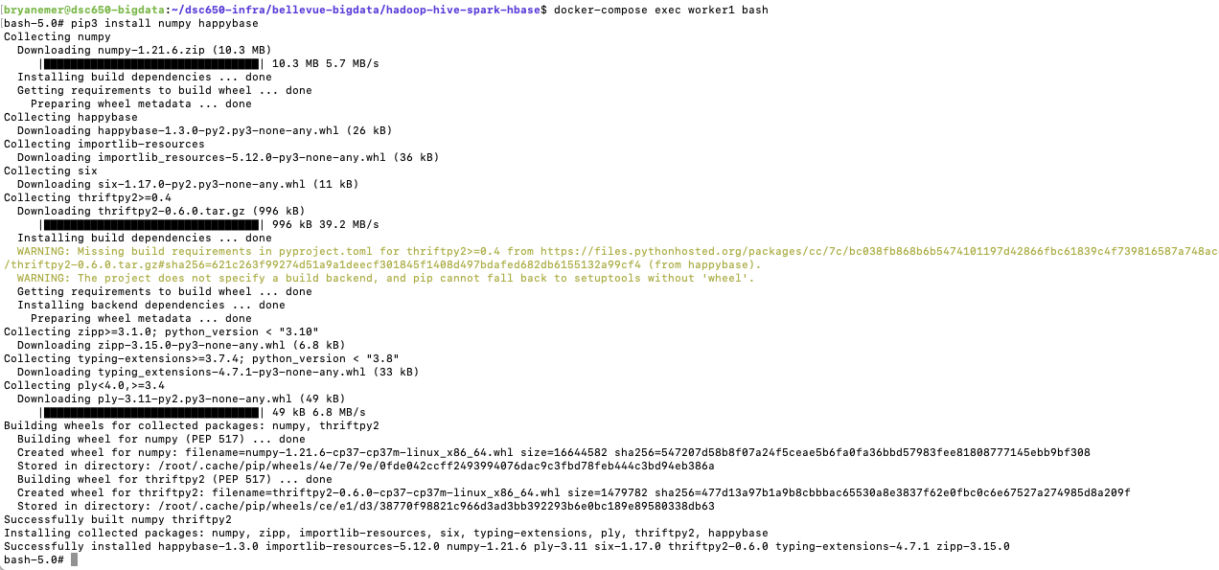
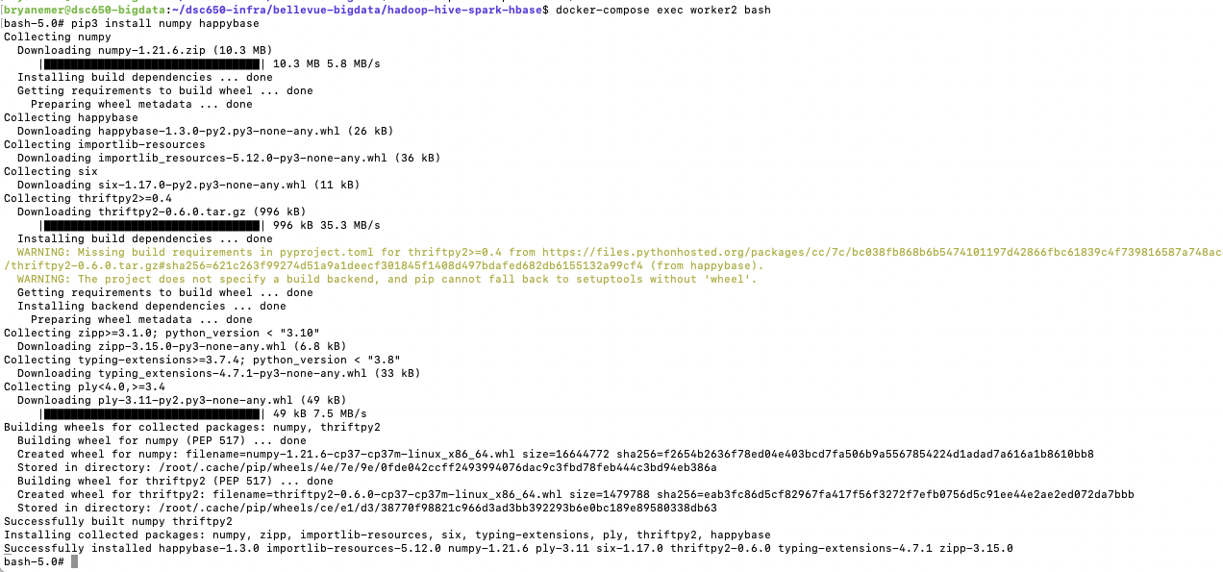
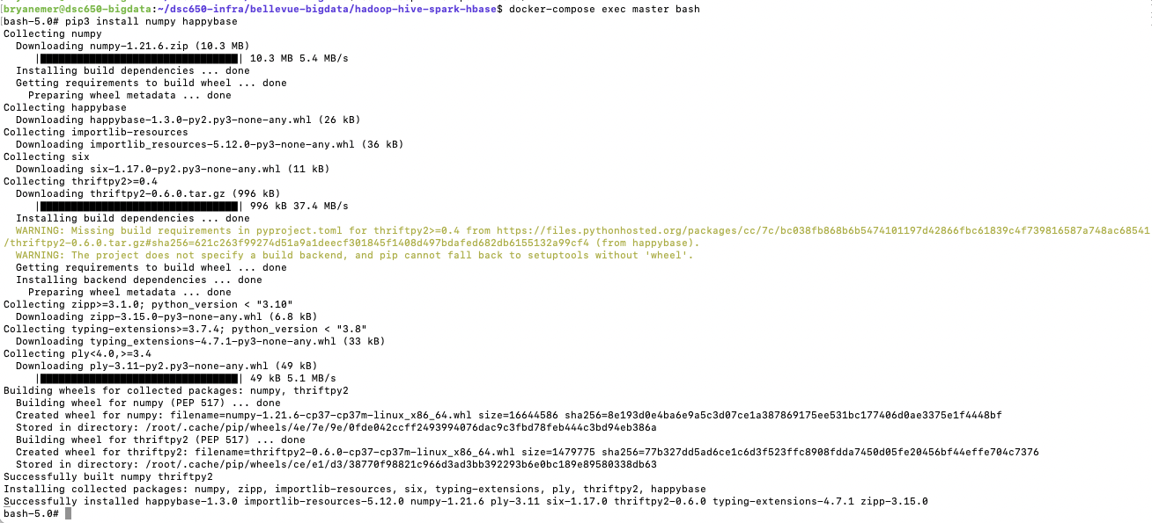
HBase Thrift Server -
Numpy is required because PySpark's MLlib internally relies on NumPy arrays for vector operations during feature assembly and model training. happybase is a Python client library that communicates with HBase over the Thrift protocol, enabling PySpark to write ML metrics directly to HBase from within the Spark job. The HBase Thrift server must be started before the PySpark script runs, as it acts as a bridge between the Python happybase client and the underlying HBase Java services. Installing these on all nodes (master, worker1, worker2) ensures the libraries are available regardless of which YARN container executes each task.

Objective 4
HBase Create command -
CREATE TABLE spotify_tracks (
row_num STRING,
track_id STRING,
artists STRING,
album_name STRING,
track_name STRING,
popularity INT,
duration_ms INT,
explicit INT,
danceability FLOAT,
energy FLOAT,
track_key INT,
loudness FLOAT,
mode INT,
speechiness FLOAT,
acousticness FLOAT,
instrumentalness FLOAT,
liveness FLOAT,
valence FLOAT,
tempo FLOAT,
time_signature INT,
track_genre STRING
)
ROW FORMAT DELIMITED
FIELDS TERMINATED BY ','
STORED AS TEXTFILE
TBLPROPERTIES ("skip.header.line.count"="1");

HBase Empty Scan -
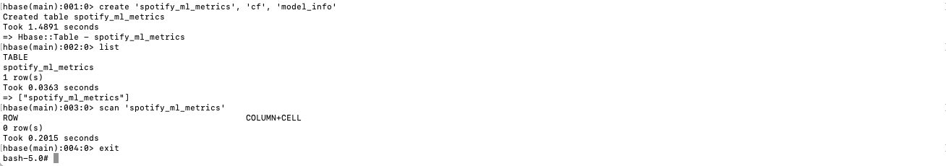
The HBase table spotify_ml_metrics uses the row key metrics_run_1 (or timestamped variants like run_20260228) to uniquely identify each ML job execution, allowing multiple runs to be stored without overwriting. The cf column family stores numeric performance metrics (RMSE, R², MAE), while the model_info column family stores descriptive metadata about the run (algorithm used, feature list, dataset size). This two-family design follows the HBase pattern of separating frequently accessed operational data (cf) from less frequently accessed metadata (model_info).

Objective 5/Objective 6
Spark-submit command -
Spark Evaluation metrics -
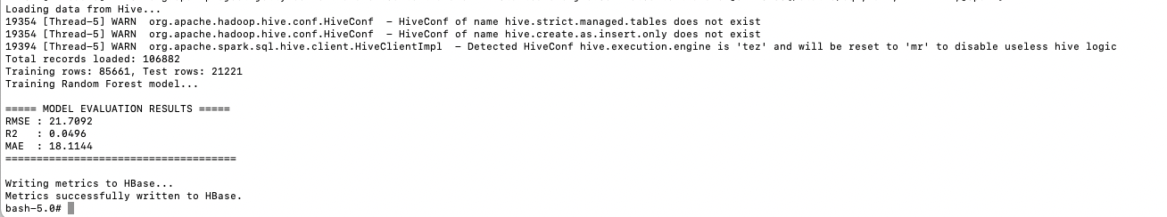

Spark code running successfully -
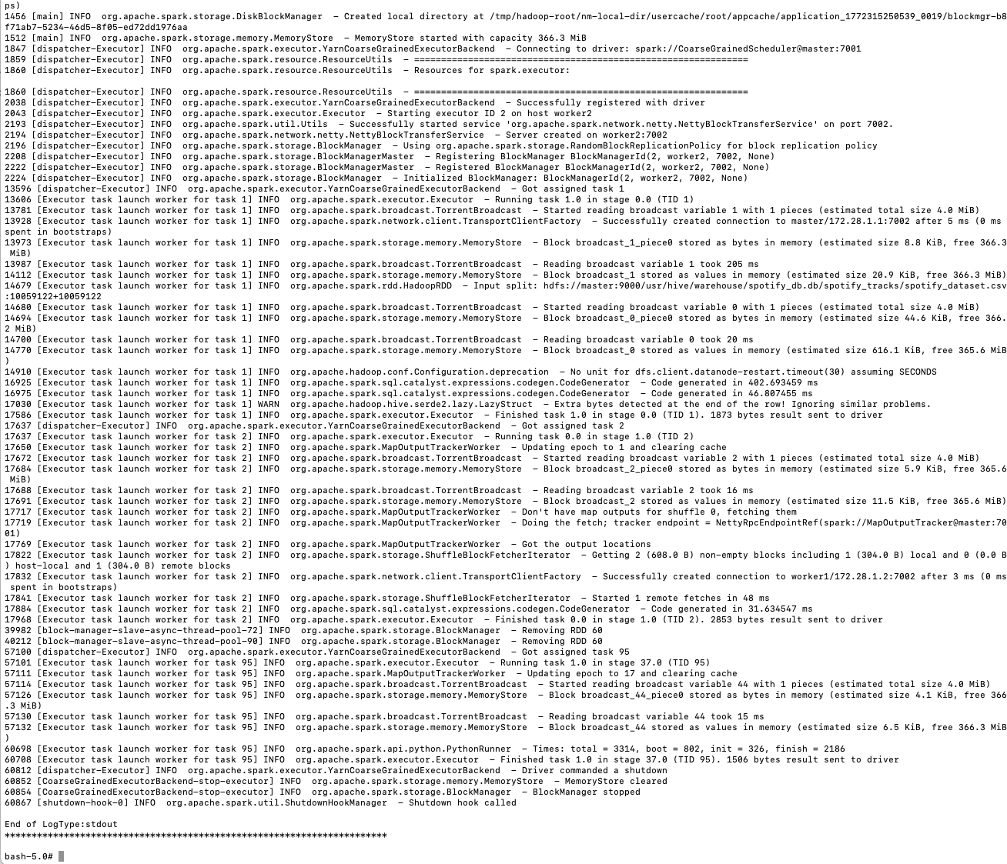
This script implements a Random Forest Regressor to predict a Spotify track's popularity score (0–100) from 13 audio features including danceability, energy, tempo, valence, loudness, and acousticness. Random Forest was chosen over simple Linear Regression because popularity is influenced by complex, non-linear interactions between features - for example, a high-energy track may be popular in some genres but not others. The pipeline chains a VectorAssembler (to combine features into a single vector) and the RandomForestRegressor. With 50 trees and a max depth of 6, the model is powerful enough to capture feature interactions without overfitting on this 114K-row dataset. Metrics (RMSE, R², MAE) are written to HBase with rich metadata in a second column family to fully document the experiment run.

Objective 7
HBase populated scan -
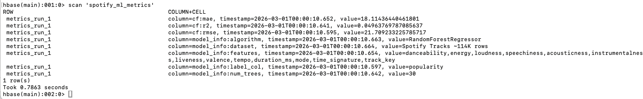
After the spark-submit job completes, scanning spotify_ml_metrics in HBase shows the row metrics_run_1 populated with six columns across two column families. The cf family contains the numeric evaluation metrics: RMSE (root mean squared error of the popularity prediction), R² (proportion of variance explained), and MAE (average absolute prediction error). The model_info family stores the algorithm name, label column, number of trees, feature list, and dataset description. This scan confirms full end-to-end pipeline success: data was ingested by NiFi, stored in HDFS, queried by Hive, processed by Spark MLlib, and the results were persisted into HBase, demonstrating all six required ecosystem components working together.

Code
NiFi Template -
The Final_Project.json NiFi template was used as provided. The following Parameter Context values were configured:
DOWNLOAD FILE URL = https://raw.githubusercontent.com/bemer303/bigdata/refs/heads/main/spotify_dataset.csv
FILENAME = spotify_tracks.csv
HDFS WRITE DIRECTORY = /user/spotify
USER = bryanemer

Hive Queries -
-- Create database
CREATE DATABASE IF NOT EXISTS spotify_db;
USE spotify_db;

-- Create managed table
CREATE TABLE spotify_tracks (
row_num STRING,
track_id STRING,
artists STRING,
album_name STRING,
track_name STRING,
popularity INT,
duration_ms INT,
explicit INT,
danceability FLOAT,
energy FLOAT,
track_key INT,
loudness FLOAT,
mode INT,
speechiness FLOAT,
acousticness FLOAT,
instrumentalness FLOAT,
liveness FLOAT,
valence FLOAT,
tempo FLOAT,
time_signature INT,
track_genre STRING
)
ROW FORMAT DELIMITED
FIELDS TERMINATED BY ','
STORED AS TEXTFILE
TBLPROPERTIES ("skip.header.line.count"="1");

-- Load data
LOAD DATA INPATH '/user/spotify/spotify_tracks.csv' INTO TABLE spotify_tracks;

-- Verification query 1
SELECT COUNT(*) AS total_tracks FROM spotify_tracks;

-- Verification query 2 (aggregation)
SELECT track_genre,
COUNT(*) AS num_tracks,
ROUND(AVG(popularity), 2) AS avg_popularity,
ROUND(AVG(danceability), 3) AS avg_danceability
FROM spotify_tracks
GROUP BY track_genre
ORDER BY avg_popularity DESC
LIMIT 10;

HBase Commands -
# Create table
create 'spotify_ml_metrics', 'cf', 'model_info'

# Pre-run empty scan
scan 'spotify_ml_metrics'

# Post-run populated scan
scan 'spotify_ml_metrics'

PySpark ML Script (spotify_ml.py) -
from pyspark.sql import SparkSession
from pyspark.sql.functions import col
from pyspark.ml.feature import VectorAssembler
from pyspark.ml.regression import RandomForestRegressor
from pyspark.ml.evaluation import RegressionEvaluator
from pyspark.ml import Pipeline
import happybase

spark = SparkSession.builder \
.appName("Spotify Popularity Prediction") \
.enableHiveSupport() \
.getOrCreate()

spark.sparkContext.setLogLevel("WARN")

df = spark.sql("""
SELECT popularity, danceability, energy, loudness, speechiness,
acousticness, instrumentalness, liveness, valence, tempo,
duration_ms, mode, time_signature, track_key
FROM spotify_db.spotify_tracks
WHERE popularity IS NOT NULL
""")

df = df.na.drop()
df = df.repartition(4)

feature_cols = [
"danceability", "energy", "loudness", "speechiness",
"acousticness", "instrumentalness", "liveness", "valence",
"tempo", "duration_ms", "mode", "time_signature", "track_key"
]

for c in feature_cols + ["popularity"]:
df = df.withColumn(c, col(c).cast("double"))

df = df.na.drop()

assembler = VectorAssembler(
inputCols=feature_cols,
outputCol="features",
handleInvalid="skip"
)

rf = RandomForestRegressor(
labelCol="popularity",
featuresCol="features",
numTrees=30,
maxDepth=5,
seed=42
)

pipeline = Pipeline(stages=[assembler, rf])

train_data, test_data = df.randomSplit([0.8, 0.2], seed=42)
print(f"Training rows: {train_data.count()}, Test rows: {test_data.count()}")

print("Training Random Forest model...")
model = pipeline.fit(train_data)
predictions = model.transform(test_data)

rmse = RegressionEvaluator(labelCol="popularity", predictionCol="prediction", metricName="rmse").evaluate(predictions)
r2 = RegressionEvaluator(labelCol="popularity", predictionCol="prediction", metricName="r2").evaluate(predictions)
mae = RegressionEvaluator(labelCol="popularity", predictionCol="prediction", metricName="mae").evaluate(predictions)

print(f"\n===== MODEL EVALUATION RESULTS =====")
print(f"RMSE : {rmse:.4f}")
print(f"R2 : {r2:.4f}")
print(f"MAE : {mae:.4f}")
print(f"=====================================\n")

data = [
(b'metrics_run_1', b'cf:rmse', str(rmse).encode()),
(b'metrics_run_1', b'cf:r2', str(r2).encode()),
(b'metrics_run_1', b'cf:mae', str(mae).encode()),
(b'metrics_run_1', b'model_info:algorithm', b'RandomForestRegressor'),
(b'metrics_run_1', b'model_info:label_col', b'popularity'),
(b'metrics_run_1', b'model_info:num_trees', b'30'),
(b'metrics_run_1', b'model_info:features', ','.join(feature_cols).encode()),
(b'metrics_run_1', b'model_info:dataset', b'Spotify Tracks ~114K rows'),
]

def write_to_hbase_partition(partition):
connection = happybase.Connection('master')
connection.open()
table = connection.table('spotify_ml_metrics')
for row_key, column, value in partition:
table.put(row_key, {column: value})
connection.close()

rdd = spark.sparkContext.parallelize(data)
rdd.foreachPartition(write_to_hbase_partition)
print("Metrics successfully written to HBase.")
spark.stop()

spark-submit Command. -
spark-submit \
--master yarn \
--deploy-mode client \
--name Spotify_Popularity_ML \
--conf spark.executor.memory=1g \
--conf spark.driver.memory=1g \
/root/spotify_ml.py

Conclusion
This project successfully implemented a complete end-to-end big data pipeline integrating NiFi, HDFS, YARN, Hive, HBase, and Spark MLlib. The Spotify Tracks dataset, containing approximately 114,000 tracks with rich audio feature metadata, was ingested via NiFi, stored in HDFS, queried through Hive, processed by a Spark Random Forest regression model, and the resulting metrics were persisted in HBase.
The final Random Forest model used 13 audio features to predict track popularity with results captured in RMSE, R², and MAE metrics stored persistently in HBase. The populated HBase scan confirmed that all six ecosystem components operated in correct sequence, validating the pipeline as functional end-to-end. This project demonstrated both the technical implementation skills required to build distributed data pipelines and the debugging skills necessary to operate them reliably under real constraints.

